**­­­Eisha Fatima**

**41769**

**BSCS – 6th**

**Computer Networks – Lab 3**

**Task 1:**

What is Ethernet cable? What type Ethernet cable is most commonly used in LAN network?

**Answer:**

**An Ethernet cable allows the user to connect their devices such as computers, mobile phones, routers, etc., to a Local Area Network (LAN) that will allow a user to have internet access, and able to communicate with each other through a wired connection.**

**Types of Ethernet Cables:**

**Mainly there are three types of Ethernet cables used in LANs**

* **Coaxial Cables**

**A coaxial cable is used to carry high-frequency electrical signals with low losses. It uses 10Base2 and 10Base5 Ethernet variants. There are 3 types of Coaxial Cables: Hardline Coaxial Cable, RG-6 Coaxial Cable and Tri-Axial Cable**

* **Twisted Pair Cables**

**A twisted pair is a copper wire cable in which two insulated copper wires are twisted around each other to reduce interference or crosstalk. It uses 10BASE-T, 100BASE-T, and some other newer Ethernet variants. It uses RJ-45 connectors.**

* **Fiber optic Cables:**

**Fiber optic cables use optical fibers which are made of glass cores surrounded by several layers of covering material generally made of PVC or Teflon. It uses 10BaseF, 100BaseFX, 100BaseBX, 100BaseSX, 1000BaseFx, 1000BaseSX, and 1000BaseBx Ethernet variants. Hence, it is capable of carrying information at a great speed.**

**Currently there are seven categories of Ethernet cable in the market CAT5, CAT5E, CAT6, CAT6A, CAT7, CAT7A, and CAT8.**

**Task 2:**

What is a LAN (local area network)? When and why to use LAN cable to sendfiles from one computer to another?

**Answer:**

**A local area network (LAN) is a collection of devices connected together in one physical location, such as a building, office, or home. A LAN can be small or large, ranging from a home network with one user to an enterprise network with thousands of users and devices in an office or school.**

**You can use Ethernet cable or LAN cable to migrate files between two computers, when you don't have access to a wireless network**

**Task 3:**

How Does LAN Work? What is meant by 127.0.0.1 and localhost?

**Answer:**

A local area network (LAN) consists of a series of computers linked together to form a network in a circumscribed location. **Localhost is the default name of the computer you are working on. The term is a pseudo name for 127.0. 0.1, the IP address of the local computer. This IP address allows the machine to connect to and communicate with itself**

**Task 4:**

How two computers can share files through disk sharing?

**Answer:**

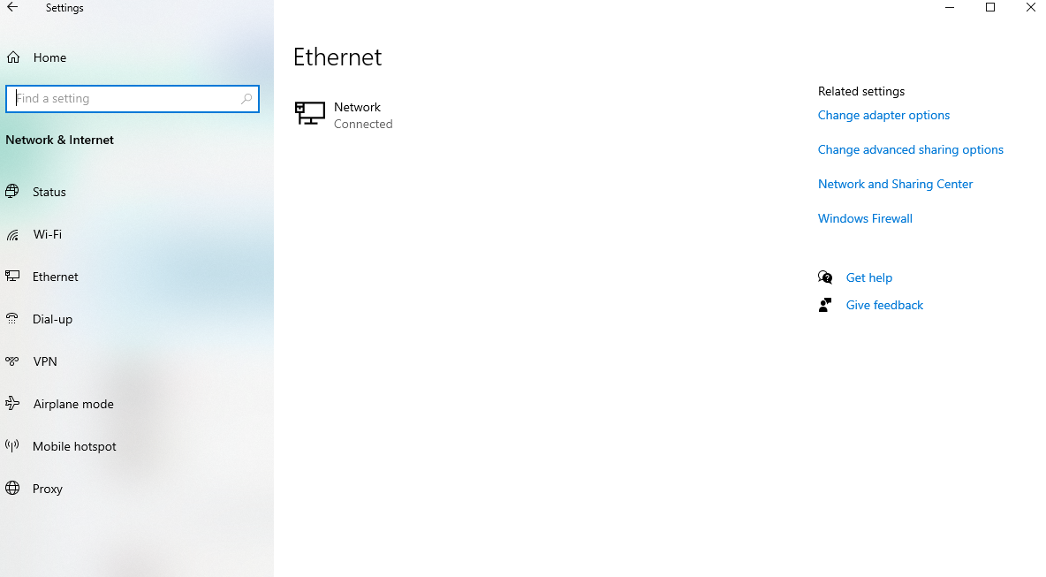

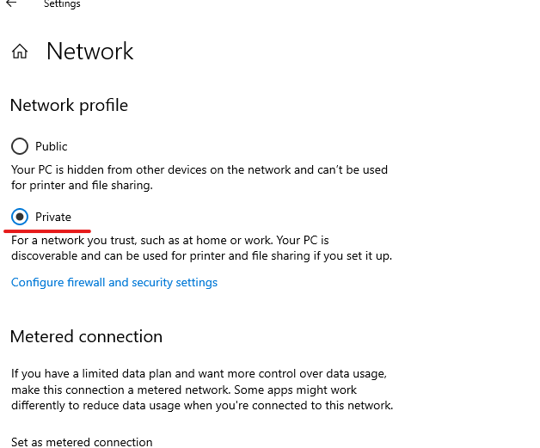

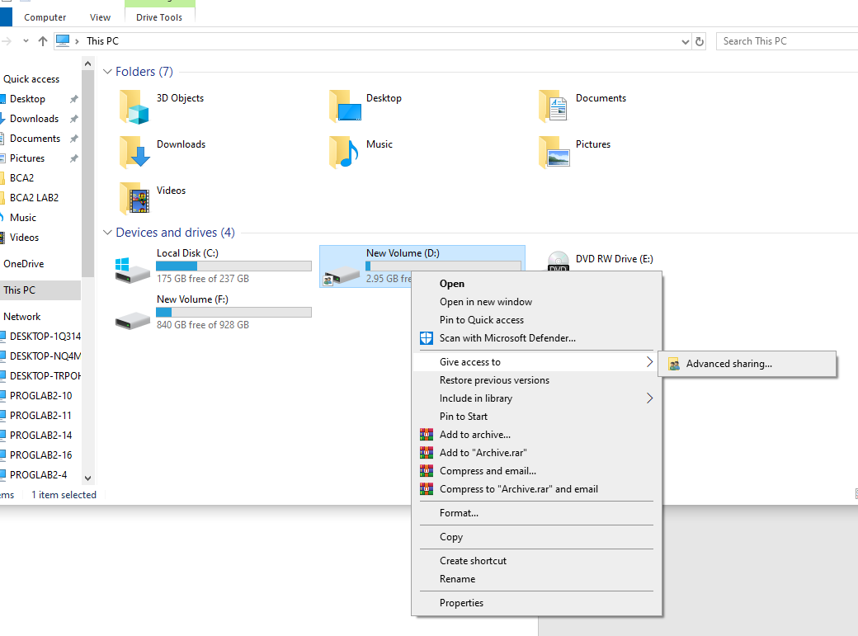

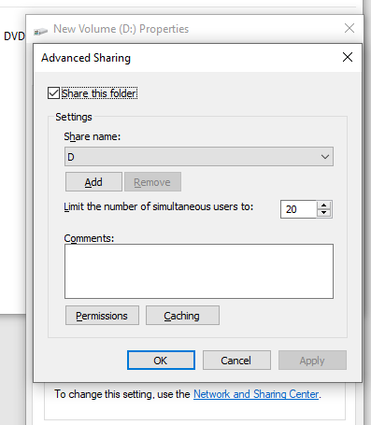

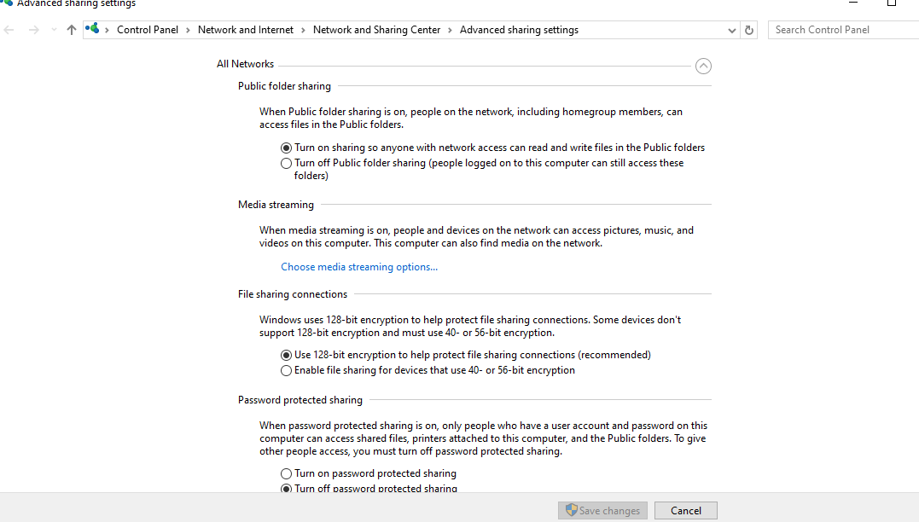

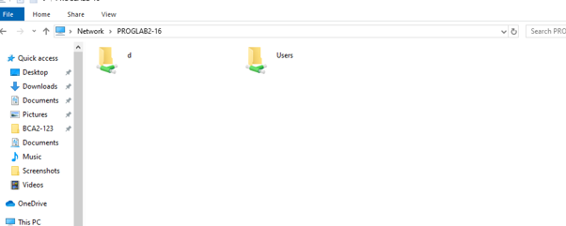

* Through IP address:

